Find the tallest person from queue

"Suppose there are a long queue of people .the number of people is unknown but we know the height of people .find out the tallest person of the queue .using the data structure link list .we need to searching the maximum value from the link list ."

code

#include<iostream>

using namespace std;

class node

{

public:

int data;

node *next;

};

class list

{

node *start, *end;

int node_count;

public:

list()

{

start= NULL ;

node_count=0;

}

void create_end(int);

void display();

void largestEl();

};

void list::create_end(int el)

{

node *current;

node_count=node_count+1;

if(start == NULL)

{

start=new node;

start->data=el;

start->next=NULL;

end=start;

}

else

{

current=new node;

current->data=el;

current->next=NULL;

end->next=current;

end=current;

}

}

void list::largestEl()

{

node *current=start;

int max = INT_MIN;

while(current!=NULL)

{

if(max<current->data)

max=current->data;

current=current->next;

}

cout<<max<<" ";

}

void list::display()

{

node *current;

current = start;

while(current!=NULL)

{

cout<<current->data<<" ";

current=current->next;

}

}

int main()

{

list l;

l.create_end(4);

l.create_end(5);

l.create_end(6);

l.create_end(3);

l.create_end(2);

l.create_end(7);

cout<<"People Hight's Are: \n";

l.display();

cout<<"\nTallest People is: ";

l.largestEl();

}

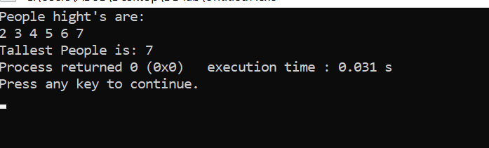

Simulation

